Air Quality Phase 2 Validation Report
Alfredo Hernandez, Jose Perla
Computer Science Department
University of Houston
Houston, TX USA
Abstract—This validation section evaluates the final air quality forecasting model developed for the Houston AQI prediction pipeline. The validation phase focused on determining whether the final Autoencoder plus Long Short-Term Memory (AE+LSTM) model could generalize to an unseen dataset that was processed using the same methods as the training dataset. This final validation approach improved the reliability of the evaluation because the unseen dataset was aligned to the same column handling, feature selection, scaling assumptions, lag design, and 24-hour sequence construction used during training. Under this corrected validation setup, the AE+LSTM achieved an external RMSE of 3.1080, MAE of 1.8214, and R-squared of 0.9094, substantially outperforming the mean baseline. However, traditional machine learning models still performed better, with Ridge Regression achieving the best external RMSE of 1.1392 and R-squared of 0.9873. Feature analysis showed that recent AQI lag features, especially us_aqi_past_1 through us_aqi_past_4, were the strongest predictors, while PM2.5 and ozone lag features provided additional signal. The Autoencoder usefulness test showed that the AE+LSTM slightly outperformed a raw-feature LSTM, suggesting that feature compression provided a modest improvement. Overall, the final validation phase showed that the neural model is valid relative to a naive baseline and improved compared with earlier attempts, but the current dataset is still better modeled by strong traditional baselines.
- Introduction
The validation phase is the final stage of the air quality prediction pipeline. Its purpose is to test whether the trained model can make accurate predictions on data that was not used during training. This distinction is important because a model can perform well on internal validation data while still failing to generalize to future or unseen observations. For an AQI forecasting system, the most meaningful test is whether the model can predict AQI values across later timestamps and across Houston-area ZIP codes using the same feature structure that would be available in a real forecasting workflow.
Earlier validation attempts revealed several problems that made it difficult to determine the true validity of the neural model. Some validation datasets were not processed in the exact same way as the training data, and earlier models were sensitive to feature mismatch, excessive lag features, missing values, and inconsistent handling of engineered columns. As a result, earlier AE+LSTM outputs sometimes appeared centered around the mean or showed unstable prediction behavior. The final validation phase corrected these issues by using an unseen external validation dataset that was processed with the same assumptions as the training dataset.
This section only discusses the validation phase. The data collection, preprocessing, exploration, and training stages are discussed by the other project teams. The validation contribution is to evaluate the final model, compare it against traditional baselines, identify when and where the model performs best or worst, and determine which features most strongly influence AQI prediction.
- definitions
Internal Validation. Model evaluation performed using a validation split derived from the same overall training dataset. It helps show whether the model learned the training distribution, but it does not prove generalization to future data.
External Validation. Model evaluation performed on a separate unseen dataset that was not used during training. This is the most important validation step because it measures generalization beyond the training distribution.
Unseen Dataset. A dataset withheld from model training and used only after the model has already learned its parameters. In this phase, the unseen dataset represented later Houston-area AQI observations.
Mean Baseline. A simple reference model that predicts the average AQI value. If a trained model cannot outperform this baseline, then it is not meaningfully better than predicting the average every time.
Traditional Machine Learning Baseline. A non-neural comparison model such as Ridge Regression, ElasticNet, Gradient Boosting, Random Forest, Linear Regression, or K-Nearest Neighbors.
Permutation Importance. Permutation importance is a feature-importance technique that measures how much a model’s error increases when one feature is randomly shuffled. If shuffling a feature causes a large decrease in model performance, then that feature is considered important. This method was used to identify which variables most affected the best traditional model’s AQI predictions.
Spearman Correlation. A correlation method that measures monotonic relationships. It was used to help identify features that consistently move with AQI.
Residual Error. The difference between the true AQI value and the predicted AQI value.
Distribution Shift. A difference between the statistical properties of the training data and the unseen validation data.

- methodology
- Technical Requirements
The validation phase was executed using a Python-based machine learning pipeline. The notebook used common data science and machine learning libraries for data loading, preprocessing, model evaluation, baseline comparison, feature importance, and visualization. The final hardware and system specifications used for this phase are listed below.
Item | Specification
Operating System | Windows
Processor | Intel i9 14900F 2.1GHz
Memory | 32GB DDR5 RAM
GPU | NVIDIA RTX 5070 12GB VRAM
Python Version | Python 3
Main Libraries | PyTorch, NumPy, pandas, scikit-learn, matplotlib
Execution Environment | Jupyter Notebook
Notebook File | final_aiq_validation.ipynb

- Validation Objective
The objective of validation was to determine whether the final AQI forecasting model could generalize beyond its training distribution. The final validation phase focused on five questions: whether the AE+LSTM beat a naive mean baseline, whether it could compete with traditional machine learning models, whether error varied by ZIP code or timestamp, which features most influenced AQI predictions, and whether the Autoencoder improved the LSTM compared with a raw-feature LSTM.
The validation stage therefore served two purposes. First, it measured predictive performance using external data. Second, it explained why the model performed the way it did by analyzing feature importance, distribution shift, residual behavior, and grouped error patterns.
- Final Model Validation Pipeline
The final validation pipeline began by training and evaluating the final AQI model on the prepared training dataset. The training dataset originally contained 95,448 rows and 185 columns. After removing rows with required missing values, the dataset was reduced to 93,120 rows. The pipeline removed uninformative columns such as wind_speed_100m, month, day, hour, day_of_week, day_of_year, month_sin, and month_cos. It then identified cyclic features, binary features, lag features, and the 21 selected sensor and environmental feature columns used by the Autoencoder.
The Autoencoder compressed selected environmental input features into a latent representation. The LSTM then received sequence inputs built from the compressed Autoencoder representation, selected lag features, and remaining binary features.
The final internal validation metrics were strong: RMSE = 2.6116, MAE = 1.5251, and R-squared = 0.9320. These results showed that the model could learn the training distribution. However, the main test of validity was external validation on unseen data.
- Unseen Dataset Alignment
The most important change in the final validation phase was the alignment of the unseen validation dataset to match the training pipeline. The external validation dataset initially contained 25,608 rows and 185 columns. The validation pipeline checked for missing columns, removed extra columns where needed, applied the same column drops used during training, and selected the same lag feature groups. After required missing-value removal, 23,280 rows remained. These rows were converted into a final external sequence tensor of shape (20,952, 24, 57), meaning the external test set contained 20,952 forecastable sequences, each with a 24-hour lookback window and 57 input features. The forecastable validation window ranged from 2026-04-07 00:00:00 to 2026-04-15 23:00:00.
This alignment step was necessary because a neural model is sensitive to feature order, feature scaling, column selection, and sequence shape. If the validation data is not processed in the same way as the training data, then the evaluation may measure preprocessing mismatch rather than true model generalization.
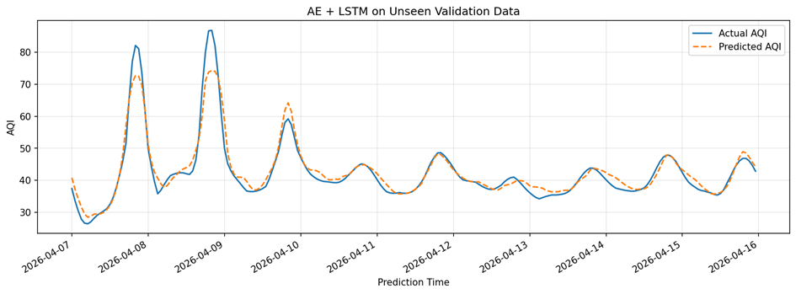
Fig.1. AE+LSTM external validation time-series comparison of actual AQI and predicted AQI.
- Validation Metrics
Three regression metrics were used to evaluate model performance: RMSE, MAE, and R-squared. RMSE measures the square-root average squared prediction error and penalizes larger errors more heavily. MAE measures the average absolute difference between predicted and actual AQI values in AQI units. R-squared measures the proportion of variance in AQI explained by the model.
The AE+LSTM was first compared against a mean baseline. The final AE+LSTM achieved an external RMSE of 3.1080, MAE of 1.8214, and R-squared of 0.9094. The mean baseline had an external RMSE of 10.3837, MAE of 6.8134, and R-squared of -0.0109. This shows that the final neural model learned meaningful AQI patterns and generalized better than a naive average prediction.
- Experiment Setup
The final validation experiment was designed to evaluate the trained AE+LSTM model under realistic unseen-data conditions. Unlike earlier attempts, the final validation process did not simply run predictions on a loosely prepared external file. Instead, it reconstructed the same preprocessing assumptions used by the training pipeline. This included matching columns, applying the same dropped-column list, selecting the same feature groups, using the same lag-window design, and building the same 24-hour input sequence format.
The training dataset contained 95,448 rows and 185 columns before required missing-value removal. After missing rows were removed, 93,120 rows remained. The model removed uninformative features and retained 21 sensor and environmental feature columns for Autoencoder compression. Lag features were selected using the final lag policy: 24 AQI lags, 8 PM2.5 lags, and 8 ozone lags.
The unseen validation dataset initially contained 25,608 rows and 185 columns. After alignment and sequence generation, the final external validation input contained 20,952 sequences. Each sequence used 24 previous hourly observations with 57 input features per time step.
The experiment evaluated four main validation tasks: AE+LSTM performance against the mean baseline, AE+LSTM comparison against traditional machine learning models, grouped analysis by timestamp and ZIP code, and feature-importance analysis. The experiment also included an ablation-style comparison between the AE+LSTM and a raw-feature LSTM to test whether the Autoencoder component improved the LSTM.
- Results
- AE+LSTM External Validation Results
The final AE+LSTM model performed well on the unseen validation dataset. It achieved an external RMSE of 3.1080, MAE of 1.8214, and R-squared of 0.9094. Compared with the mean baseline, which had an RMSE of 10.3837, MAE of 6.8134, and R-squared of -0.0109, the neural model clearly learned meaningful AQI patterns and generalized beyond the training dataset.
This result is a major improvement over earlier validation attempts. In earlier phases, the model often predicted near the mean or produced unstable predictions due to dataset mismatch, feature issues, and inconsistent preprocessing. In the final validation run, the unseen dataset was processed using the same rules as the training dataset. This produced a more reliable validation result and showed that the final AE+LSTM model was not simply memorizing or predicting the average AQI.
- Model Comparison Results
The traditional machine learning comparison showed that Ridge Regression was the best-performing external model. Ridge achieved an external RMSE of 1.1392, MAE of 0.6143, and R-squared of 0.9873. ElasticNet performed similarly with RMSE = 1.1516 and R-squared = 0.9870. Gradient Boosting and Random Forest also outperformed the AE+LSTM, with external RMSE values of 1.4164 and 1.6100 respectively.
Model | External RMSE | External MAE | External R-squared
Ridge | 1.1392 | 0.6143 | 0.9873
ElasticNet | 1.1516 | 0.6081 | 0.9870
Gradient Boosting | 1.4164 | 0.7573 | 0.9803
Random Forest | 1.6100 | 0.8176 | 0.9746
Linear Regression | 2.8050 | 1.6317 | 0.9229
AE+LSTM | 3.1080 | 1.8214 | 0.9094
KNN | 5.0319 | 3.2281 | 0.7518
Mean Baseline | 10.3837 | 6.8134 | -0.0109
These results show that the final neural model is valid in the sense that it generalizes to unseen data and beats a naive baseline. However, it is not the most accurate model in the final comparison. The best traditional models likely performed better because the dataset contains strong lag features, especially recent AQI values, that can be modeled effectively by simpler regression-based methods.
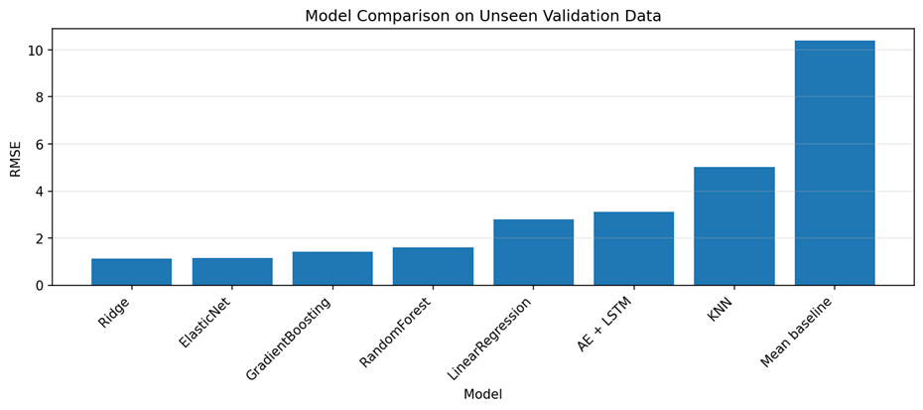
Fig.2. External RMSE comparison across all validation models
- Zip-Code Results
The grouped ZIP-code analysis showed that the AE+LSTM performed best in ZIP codes 77073, 77032, 77060, 77093, and 77037. These ZIP codes had RMSE values between 1.8134 and 1.8723, with R-squared values around 0.9456 to 0.9490. This indicates that for some regions, the AE+LSTM produced very accurate forecasts.
The worst ZIP codes were 77067, 77018, 77086, 77092, and 77040. These ZIP codes had RMSE values around 4.0089 to 4.0284, with R-squared values around 0.8881 to 0.8892. Although these errors were higher, they were still substantially better than the mean baseline. This suggests that the model remained useful across all ZIP codes, but some regions had more difficult prediction patterns than others.
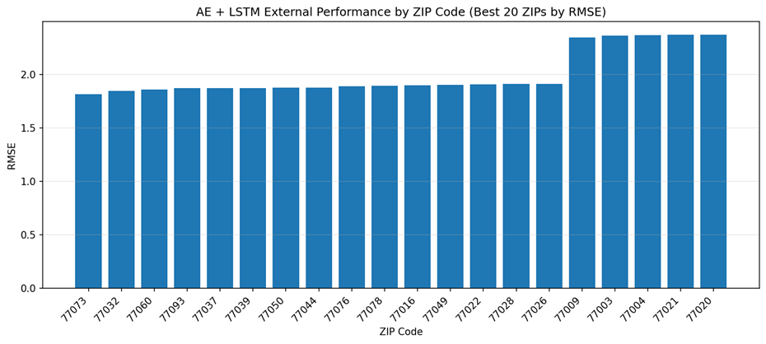
Fig.3. ZIP-code grouped external validation results for the AE+LSTM model.
- Timestamp Results
The timestamp analysis showed that the AE+LSTM performed extremely well during some hours and poorly during others. The best timestamp was 2026-04-12 01:00, with RMSE = 0.1678 and MAE = 0.1381. Other strong timestamps included 2026-04-12 07:00, 2026-04-14 11:00, 2026-04-10 01:00, and 2026-04-12 05:00.
The worst timestamps occurred primarily during the evening hours of 2026-04-07 and 2026-04-08. The worst timestamp was 2026-04-08 19:00, with RMSE = 14.2509, MAE = 12.8690, and R-squared = -4.0431. These periods likely represent short-term events or distribution shifts that the AE+LSTM did not capture well.
- Dataset Diagnostics and Distribution Shift
The validation phase included dataset diagnostics to compare the training and unseen validation datasets. Both datasets contained 97 ZIP codes and no duplicate rows. Missing values were concentrated in lag columns, which was expected because lag features cannot be calculated for the first several rows of each ZIP-code time series.
The train-versus-validation shift check showed differences in several important environmental variables. The training dataset had a PM2.5 mean of 9.2214, while the external validation dataset had a PM2.5 mean of 7.7347. Ozone increased from a training mean of 76.6495 to an external validation mean of 85.3259. Cloud cover increased from 49.1349 in training to 67.9503 in validation. AQI decreased slightly, from a training mean of 43.3626 to an external validation mean of 41.3027.
These differences indicate that the unseen validation period was not identical to the training period. The AE+LSTM still performed well against the mean baseline, but the traditional models generalized better, suggesting that the tabular baselines were more robust under this validation distribution.
- Feature Importance Results
Feature-importance analysis was used to determine which variables most influenced AQI prediction. The strongest pattern across the validation analysis was that recent AQI history dominated prediction performance. The highest correlated feature was us_aqi_past_1, followed by us_aqi_past_2, us_aqi_past_3, us_aqi_past_4, us_aqi_past_5, and us_aqi_past_6. PM2.5 lag features and ozone features also contributed useful information.
Permutation importance on the best traditional model produced the same conclusion. The most important features were us_aqi_past_1, us_aqi_past_2, us_aqi_past_3, and us_aqi_past_4. Other important variables included later AQI lags, ozone, and ozone lag features. This means that the best models were primarily using recent AQI history, with pollutant variables providing supporting information.
The consensus feature analysis confirmed this result through multiple methods. Spearman correlation, model-based importance, and permutation importance all identified recent AQI lags as the dominant predictors. This supports one of the main validation conclusions: the AQI forecasting problem in this dataset is strongly time-dependent, and careful lag-feature design is more important than simply adding more features.
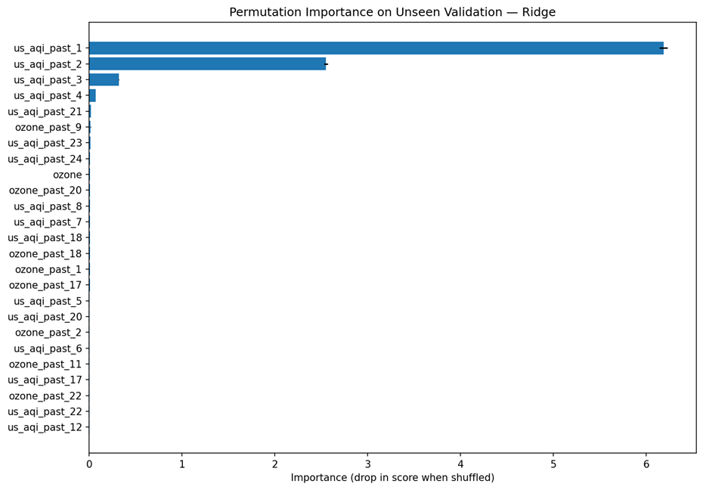
Fig..4. Top 25 permutation-importance features from the best traditional model
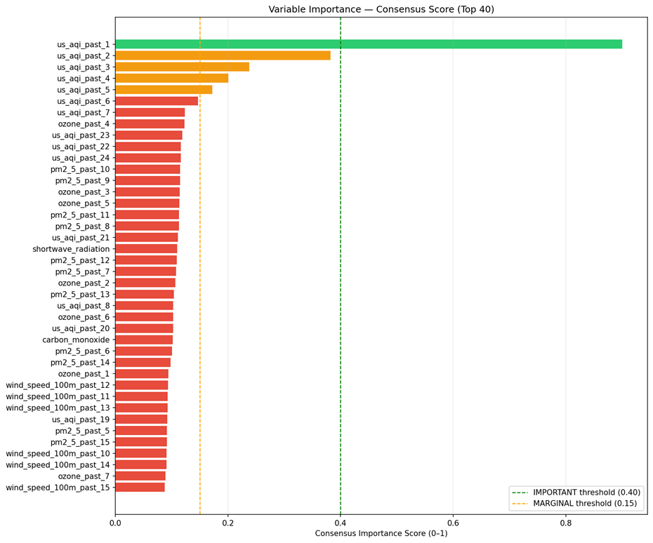
Fig.5. Consensus feature importance across validation tests
- Autoencoder Usefulness Results
The Autoencoder usefulness test showed that the AE+LSTM performed better than the raw-feature LSTM. The AE+LSTM achieved external RMSE = 3.1080, MAE = 1.8214, and R-squared = 0.9094. The raw LSTM achieved external RMSE = 3.3172, MAE = 1.8872, and R-squared = 0.8968.
This result supports the use of Autoencoder compression, but only modestly. The AE+LSTM was more accurate than the raw LSTM, which suggests that compressing selected sensor features helped reduce noise or dimensionality before temporal modeling. However, the improvement was not large enough to make the AE+LSTM outperform traditional models. Therefore, the Autoencoder appears to be useful within the neural architecture, but the overall neural architecture still needs improvement before it can become the best forecasting approach for this dataset.
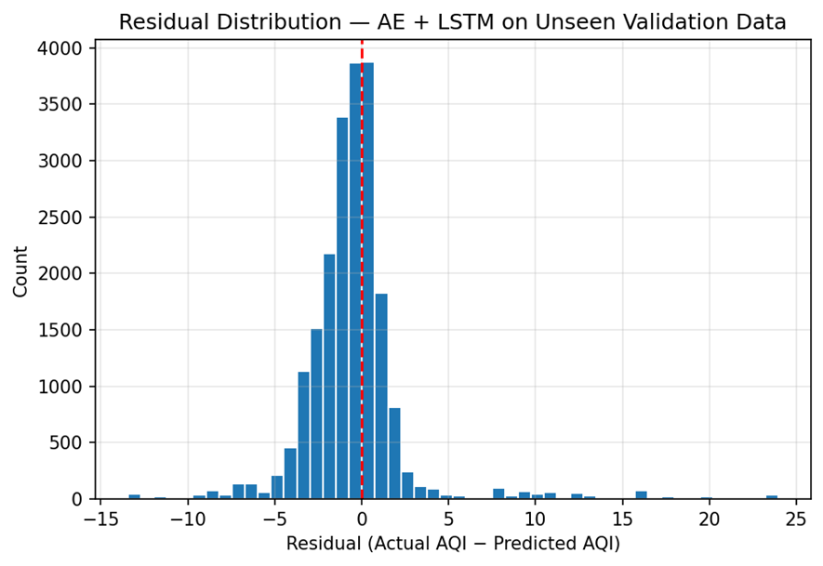
Fig.6. AE+LSTM external validation residual analysis

- Conclusions
The final validation phase showed a major improvement over earlier validation attempts. The most important change was the use of an unseen validation dataset that was processed using the same methods as the training dataset. By aligning columns, applying the same dropped-feature rules, selecting the same lag windows, and constructing the same 24-hour sequence format, the validation team produced a more accurate and meaningful test of model generalization. Under this corrected setup, the AE+LSTM achieved an external RMSE of 3.1080 and R-squared of 0.9094, strongly outperforming the mean baseline. This demonstrates that the final neural model was not simply predicting the average AQI and was able to learn meaningful temporal patterns from the dataset.
However, the final validation results also showed that the AE+LSTM was not the best-performing model overall. Traditional machine learning models, especially Ridge Regression and ElasticNet, achieved substantially lower external RMSE values. Ridge Regression was the strongest model with external RMSE = 1.1392 and R-squared = 0.9873. This suggests that the current AQI dataset contains strong linear or near-linear temporal relationships, especially through recent AQI lag features. Because these lag features are highly predictive, simpler models can use them very efficiently without needing the added complexity of a neural sequence model. The final validation phase therefore supports a balanced conclusion: the AE+LSTM is valid and improved, but traditional models remain more accurate for the current dataset.
The validation phase also provided important insight into feature behavior. Across correlation analysis, permutation importance, Spearman correlation, and model-based importance, recent AQI lag features were consistently the strongest predictors. PM2.5 and ozone lag features also contributed useful information, but the dominant signal came from recent AQI history. The
Autoencoder usefulness test showed that the AE+LSTM performed better than a raw-feature LSTM, indicating that Autoencoder compression provided a modest benefit. Future work should focus on reducing lag redundancy, testing longer unseen validation periods, improving handling of distribution shift, and comparing model performance across more varied AQI conditions. Overall, the final validation phase showed that the pipeline can produce reliable forecasts, but it also demonstrated the importance of comparing neural models against strong traditional baselines before deciding which model is most suitable for deployment.
- Contributions
The validation and result evaluation were carried
out by Validation team members Alfredo Hernandez and Jose Perla, whose feedback on feature importance particularly the significance of lag features guided
improvements from Iteration 1 to Iteration 3. The dataset preprocessing pipeline, cyclic feature encoding, performance testing of Autoencoder , and lag feature
construction were shared contributions across the team.

